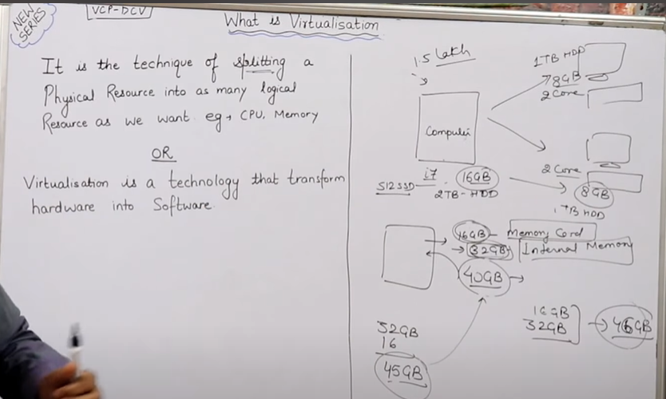

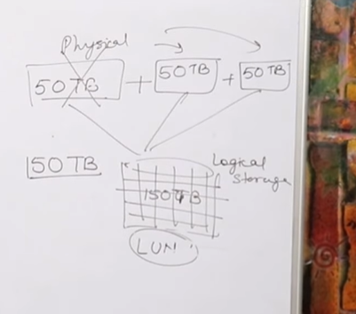33

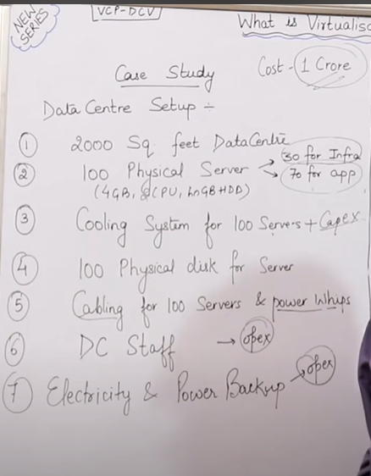

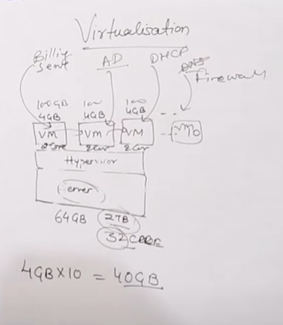

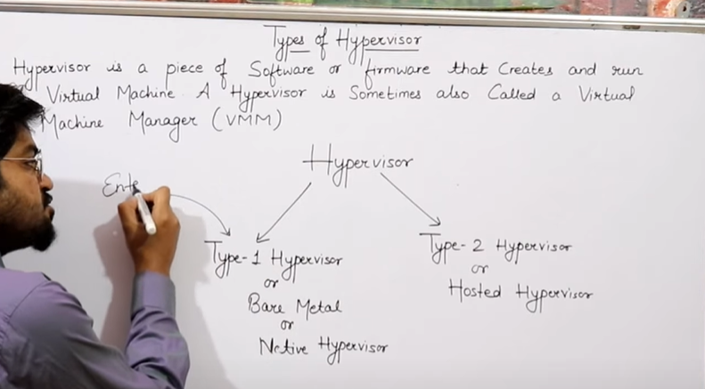

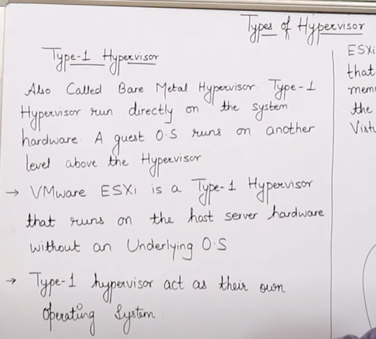

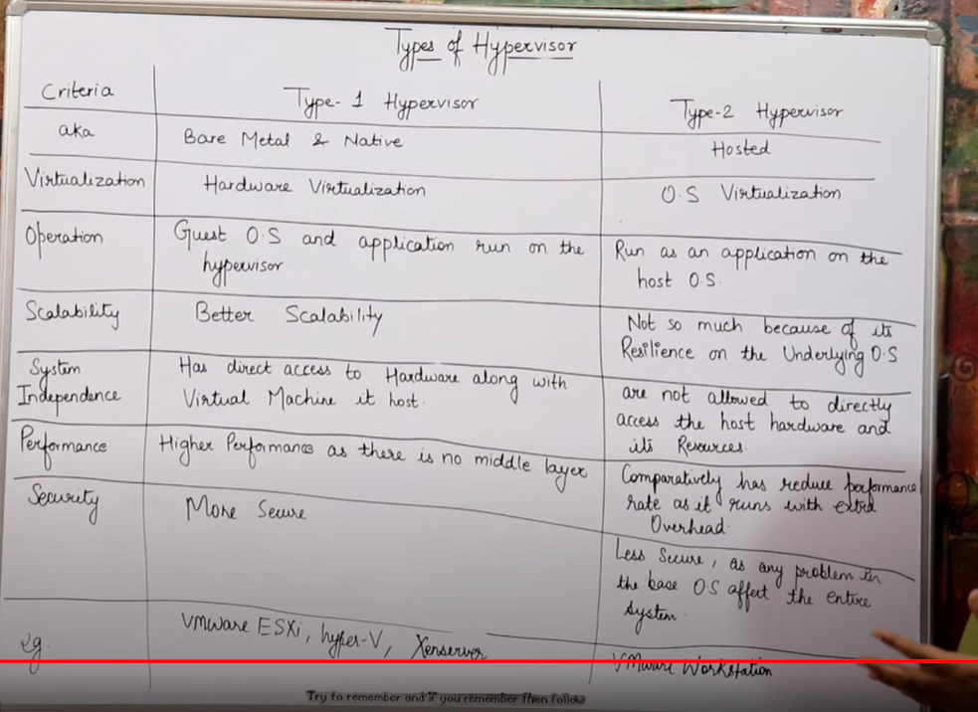

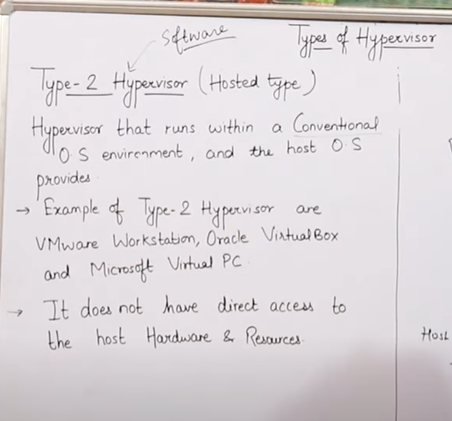

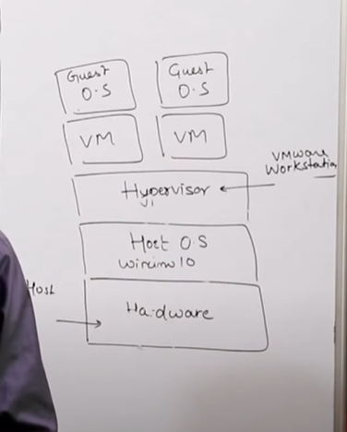

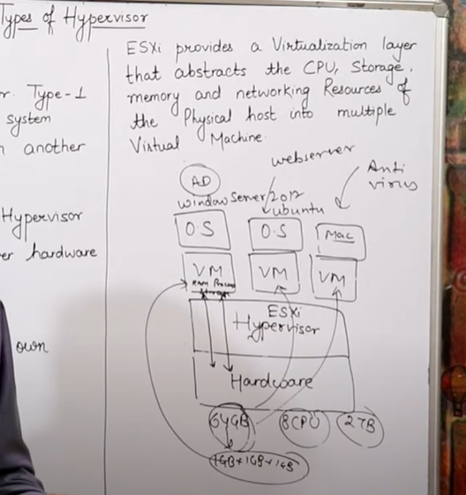

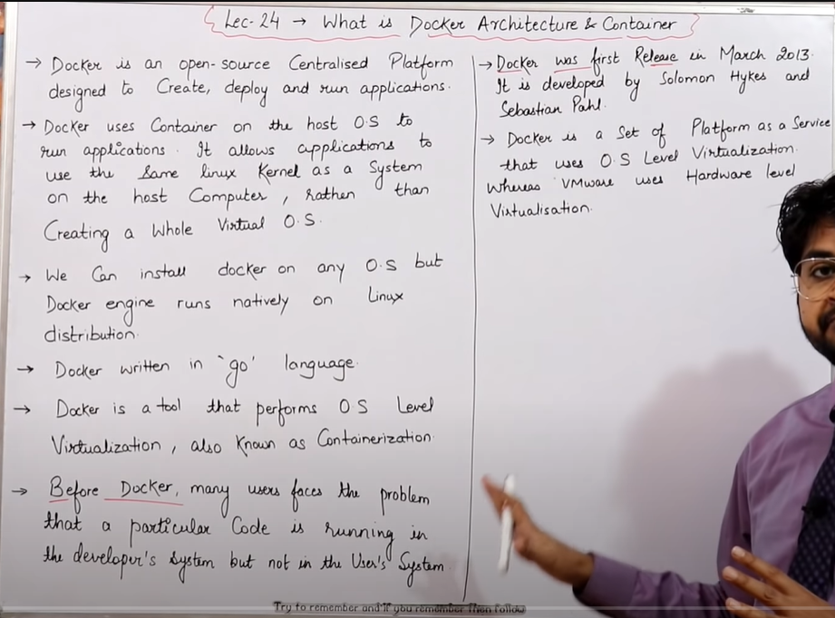

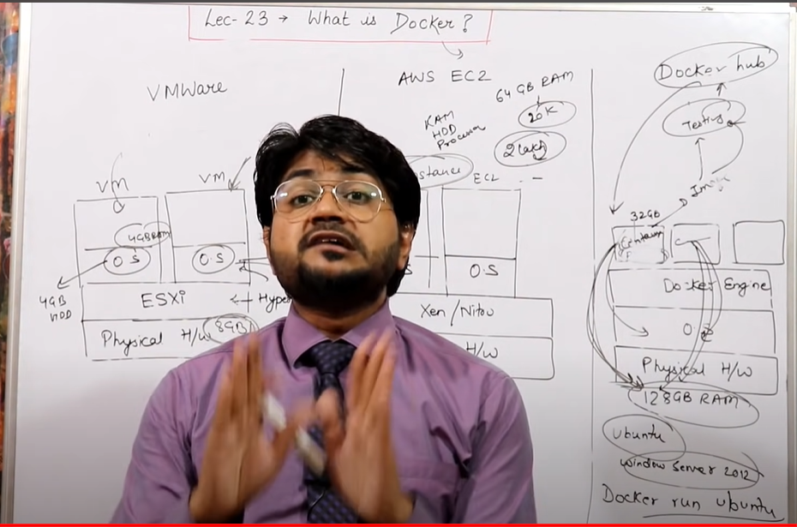

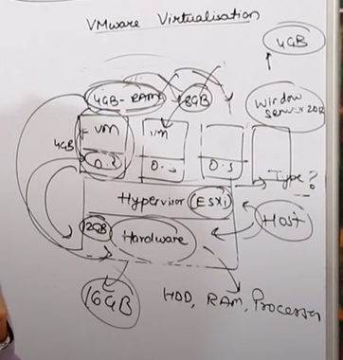

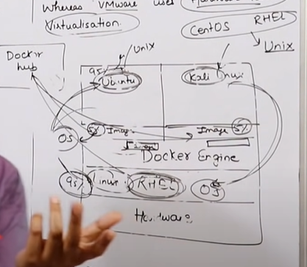

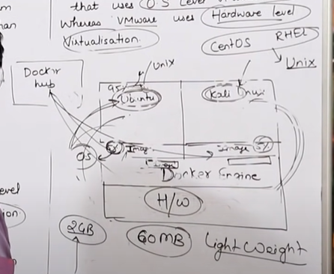

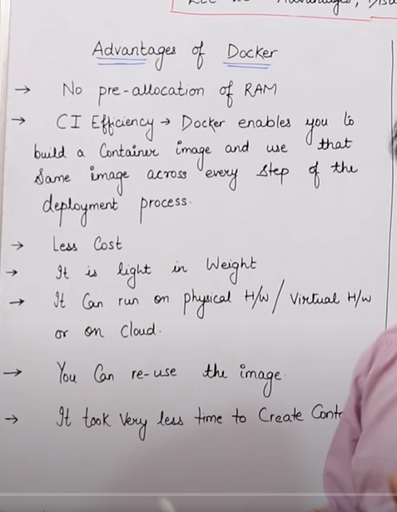

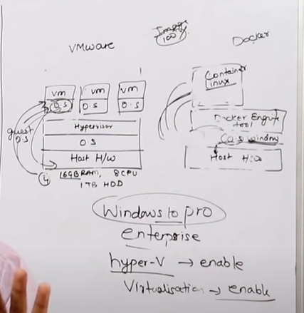

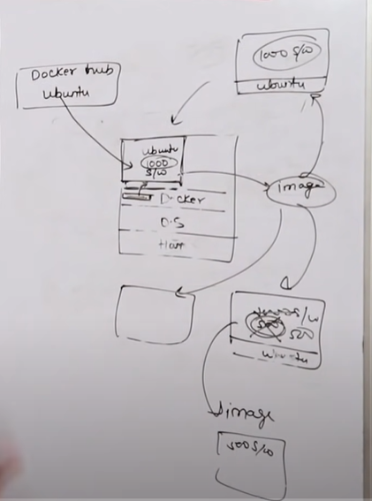

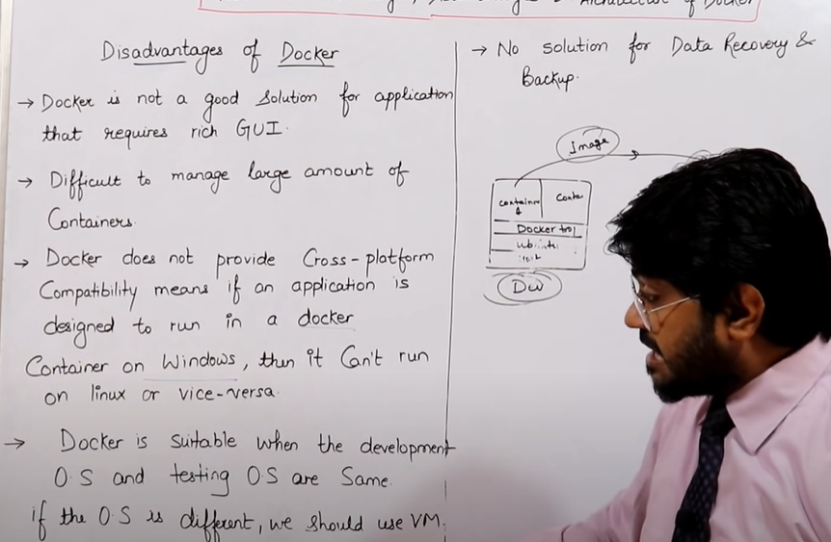

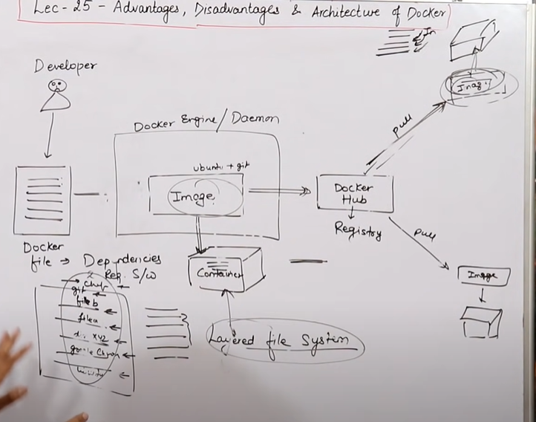

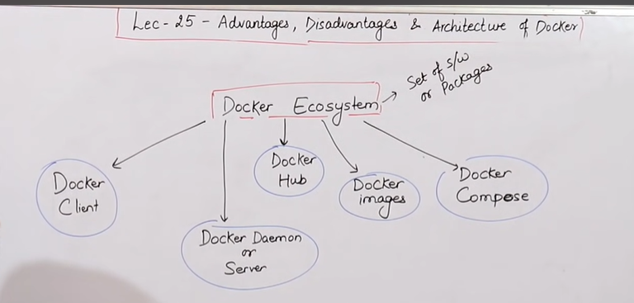

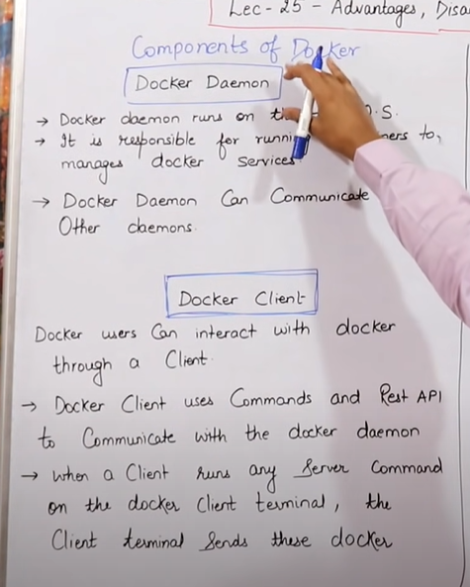

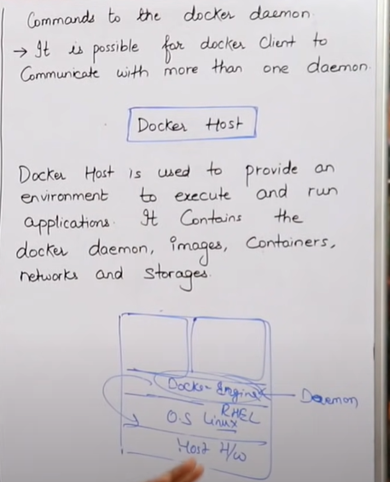

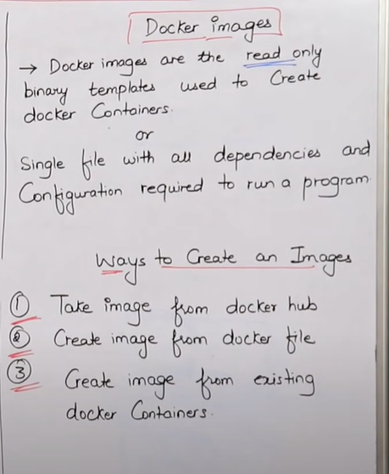

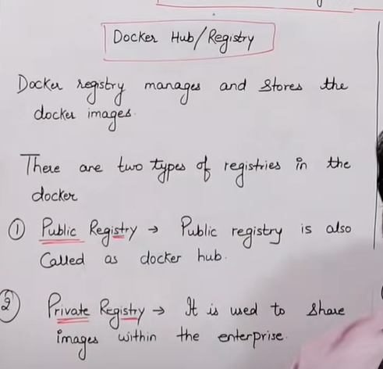

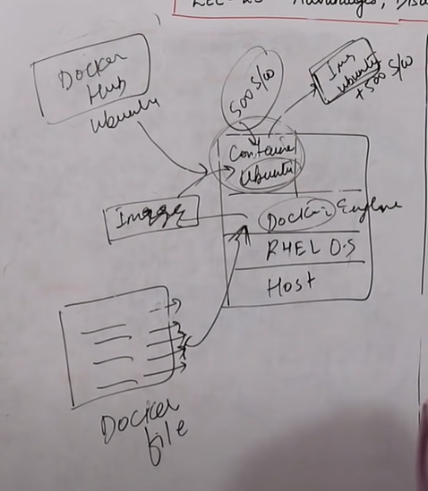

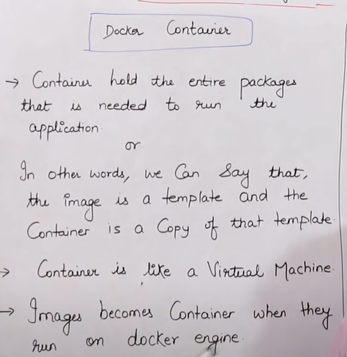

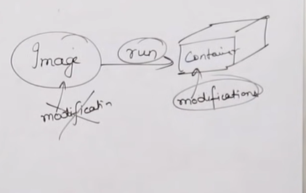

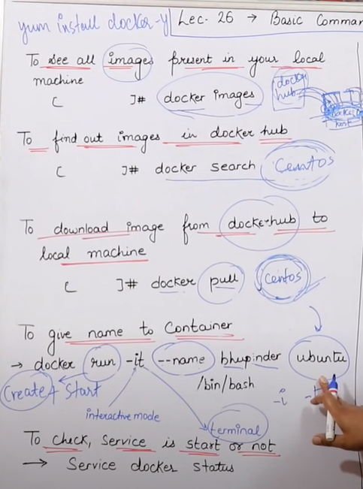

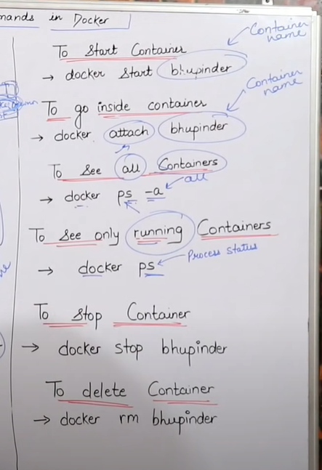

1 yum update -y

2 yum install docker -y

3 which docker

4 service docker start

5 service docker status

6 docker info

7 docker images

8 docker ps

9 docker ps -a

10 docker run -it ubuntu /bin/bash

11 docker image

12 docker images

13 docker run -it ubuntu /bin/bash

14 docker images

15 docker ps -a

16 docker run -it centos /bin/bash

17 docker images

18 docker run -it centos /bin/bash

19 docker ps -a

20 docker pull jenkins

21 docker pull jenkins

22 docker pull jenkins

23 Using default tag: latest

24 Error response from daemon: manifest for jenkins:latest not found: manifest unknown: manifest unknown

25 docker pull jenkins/jenkins

26 docker images

27 docker pull chef/chefdk

28 docker pull chef/chefworkstation

29 docker images

30 docker run -it chef/chefworkstation /bin/bash

31 docker search ubuntu

32 history

33 docker ps

34 docker ps -a

35 docker start agitated_rosalind

36 docker ps -a

37 docker attach agitated_rosalind

38 docker ps -a

39 docker start agitated_rosalind

40 docker rm agitated_rosalind

41 docker stop agitated_rosalind

42 docker rm agitated_rosalind

43 docker run -it --name nitishubconatiner ubuntu /bin/bash

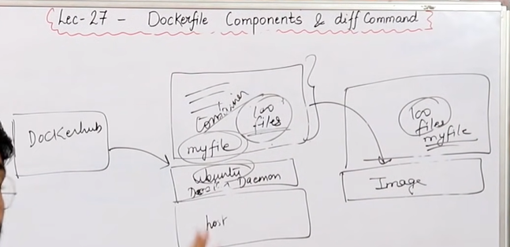

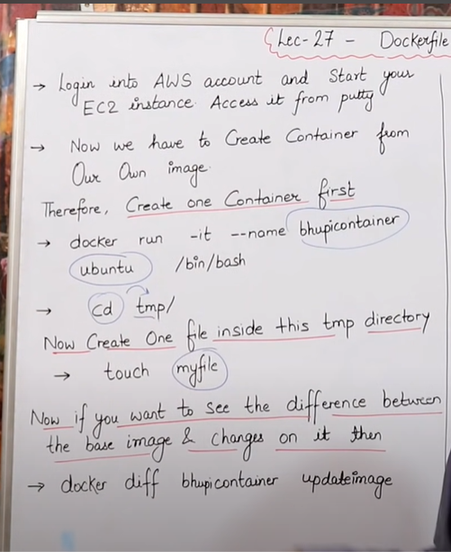

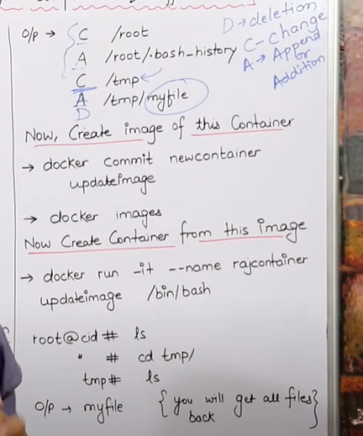

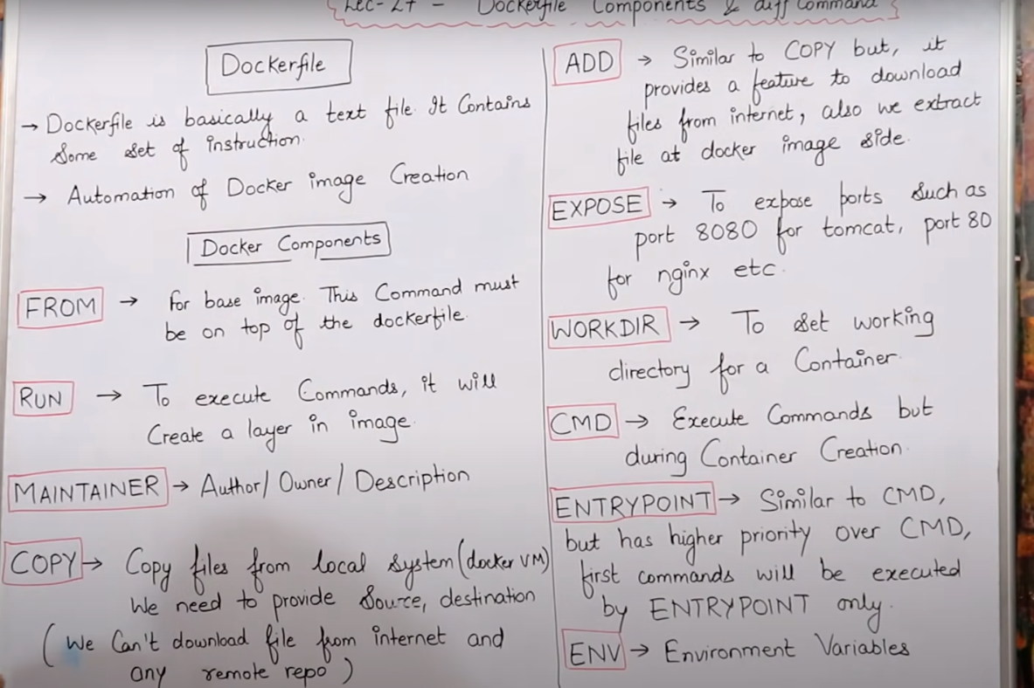

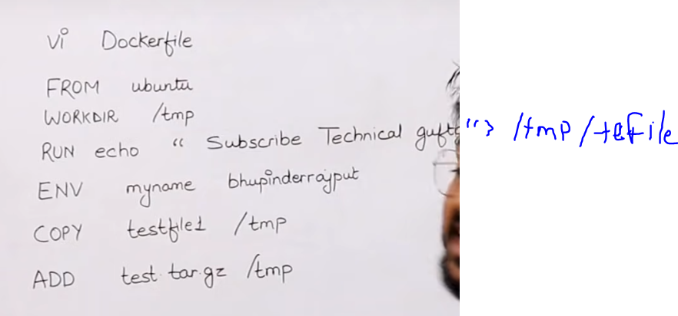

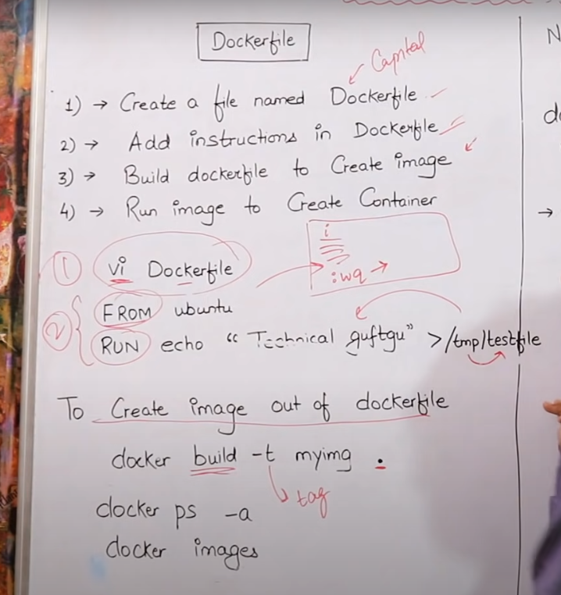

1 ps -l

2 exit

3 ifconfig

4 /etc/init.d/networking start

5 less /etc/network/interfaces

6 /bin/hostname

7 ufw status

8 apt-get install ssh

9 /etc/init.d//ssh restart

10 ifconfig

11 ufw allow ssh

12 /etc/init.d/ssh restart

13 ssh

14 ifconfig

15 ps

16 ps -l

17 service docker status

18 docker run --name bhupiconatiner -it ubuntu /bin/bash

19 service docker stop

20 service docker start

21 service docker status

22 docker run --name bhupiconatiner -it ubuntu /bin/bash

23 docker run --help

24 docker run -it --name nitishconatiner ubuntu /bin/bash

25 docker search ubuntu

26 service docker status

27 docker run -it --name nitishconatianer ubuntu /bin/bash

28 docker diff nitishconatiner

29 docker diff nitishconatianer

30 docker commit nitishcontainer updatedimage

31 docker commit nitishconatianer updatedimage

32 docker images

33 docker run -it --name nitishupconatiner updateimage

34 docker run -it --name nitishupconatiner updatedimage

35 vi Dockerfile

36 ls

37 ls -l

38 docker build -t dockerfileimag .

39 docker images

40 ls -l

41 cd Devops

42 cd devops

43 mkdir devops

44 mkdir test_docker

45 cd devops

46 mkdir tdocker

47 cd tdocker/

48 ls -l

49 vi Dockerfile

50 docker build -t test .

51 docker images

52 docker run -it --name dockfileconatiner test /bin/bash

53 ls

54 vi Dockerfile

55 touch testfile

56 cat Dockerfile

57 touch testfile1

58 tar -cvf test.tar testfile1

59 ls

60 gzip test.tar

61 ls

62 rm tetsfile1

63 rm testfile1

64 ls

65 docker build -t newimage .

66 docker images

67 ls

68 docker run -it --name newconatiner newimage /bin/bash

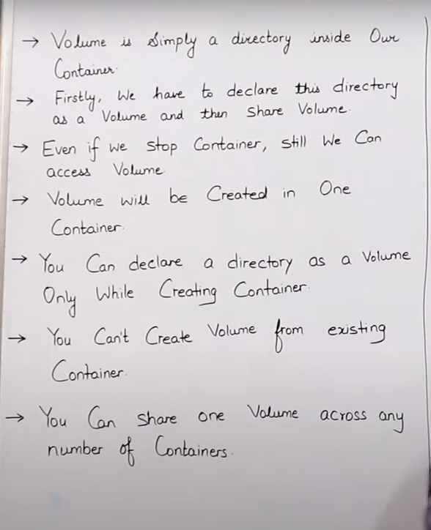

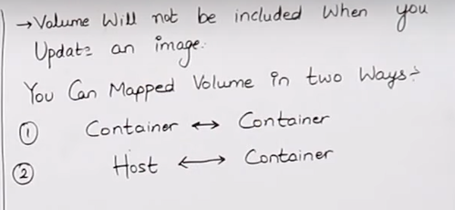

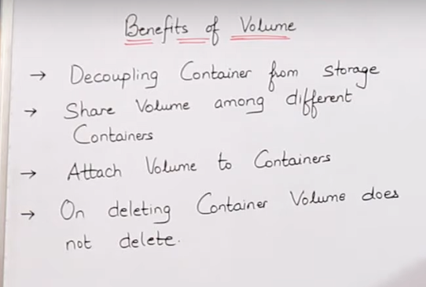

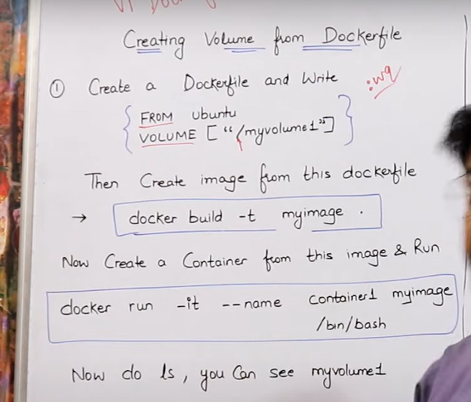

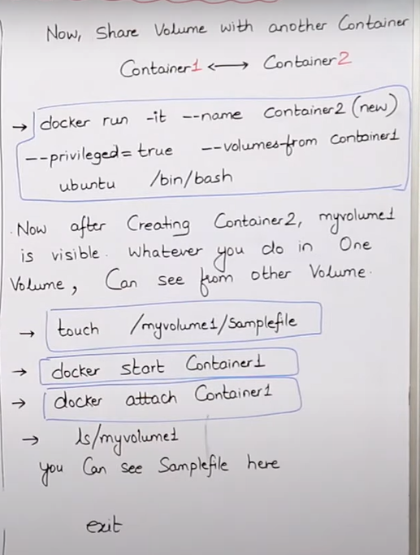

1 service docker start

2 service docker status

3 ls

4 mkdir nkplay

5 cd nkplay

6 touch file1 ,file 2

7 ls

8 touch file2

9 vi Dockerfile

10 docker build -t myimage

11 docker build -t myimage .

12 docker images

13 docker run -it --name conainer1 myimage /bin/bash

1 ls

2 cd myvolume

3 ls

4 cd..

5 cd ..

6 cd myvolume

7 touch filex filey filez

8 ls

9 history

22 docker run -it --name conainer2 --privileged=true --volumes-from conainer1 ubuntu /bin/bash

docker start conainer1

docker attach conainer1

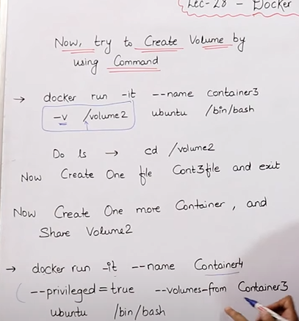

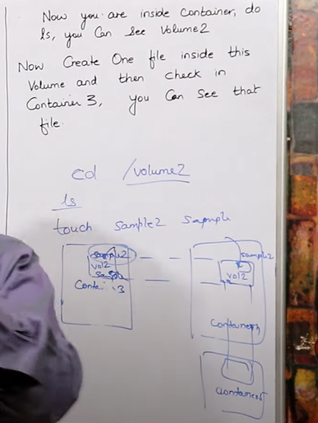

Docker Port Mapping

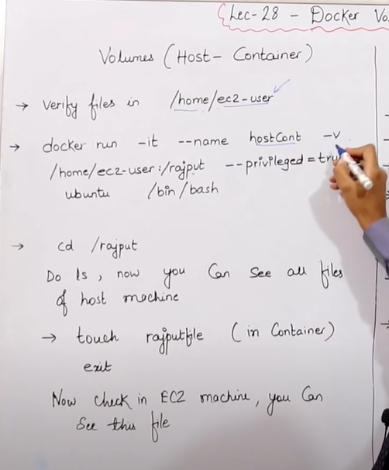

76 docker run -it --name hostcont -v /home/codenk/docker:/rajput --privileged=true ubuntu /bin/bash

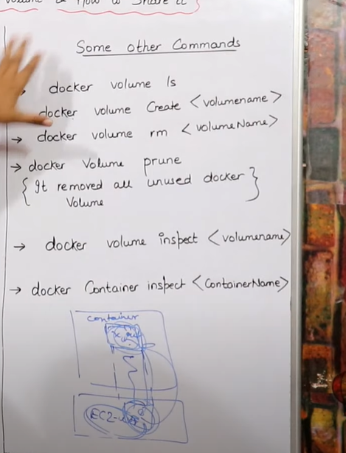

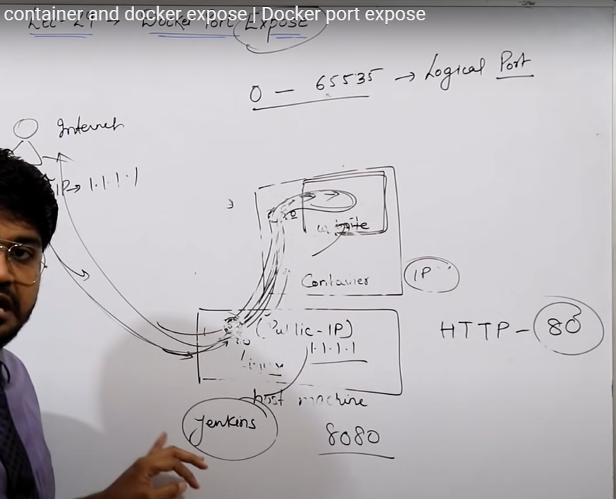

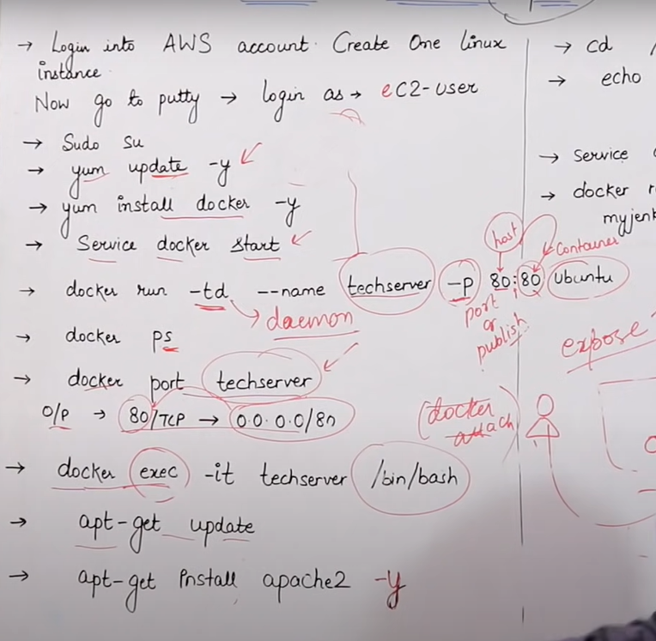

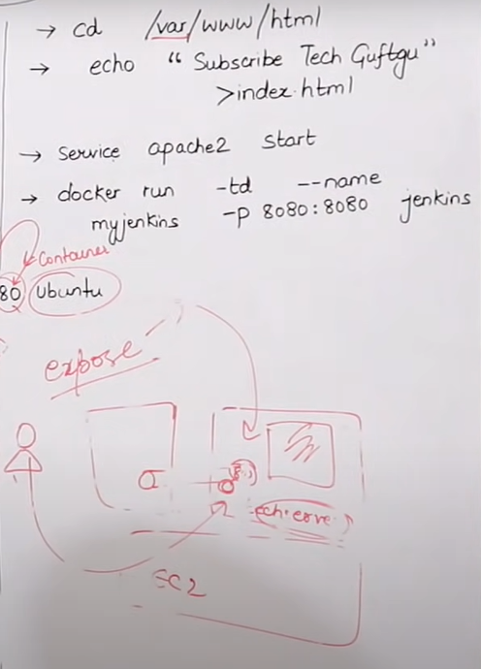

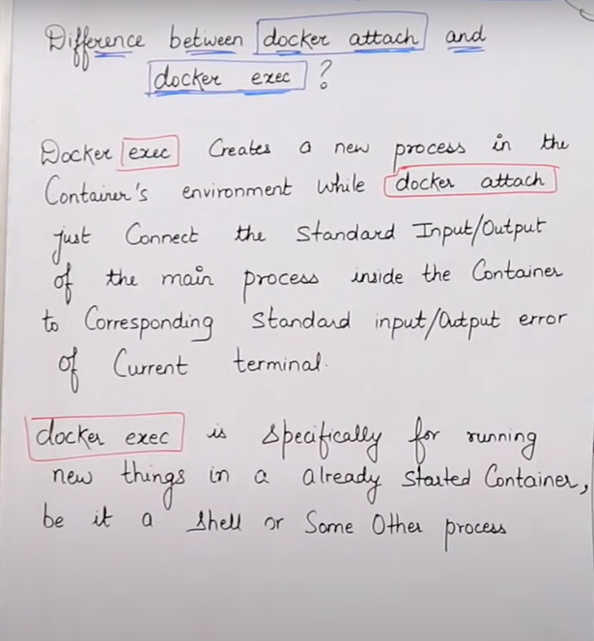

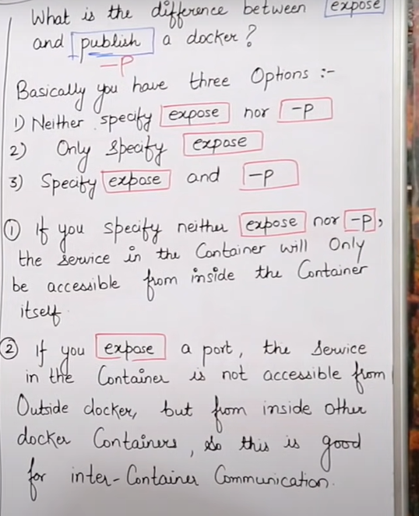

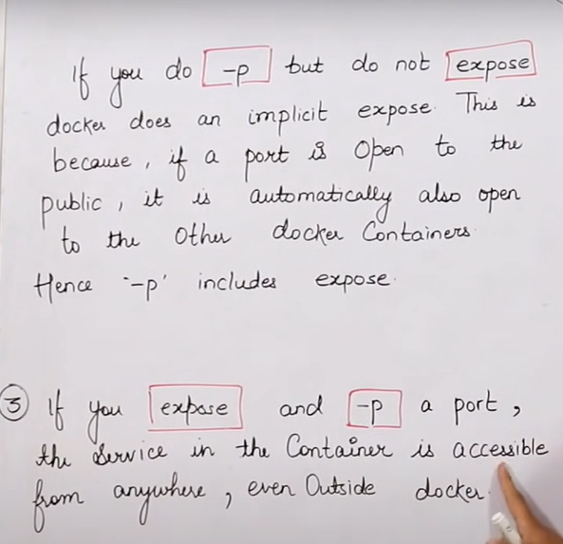

1 yum install docker -y

2 yum update -y

3 docker -v

4 service docker start

5 docker run -td --name techserver -p 80:80 ubuntu

6 docker ps

7 docker port techserver

8 docker exec -it techserver /bin/bash

9 docker run -td --name myjenkins -p 8080:8080 jenkins

10 docker run -td --name myjenkins -p 8080:8080 jenkins

11 docker run -td --name myjenkins -p 8080:8080 jenkins/jenkins

12 history

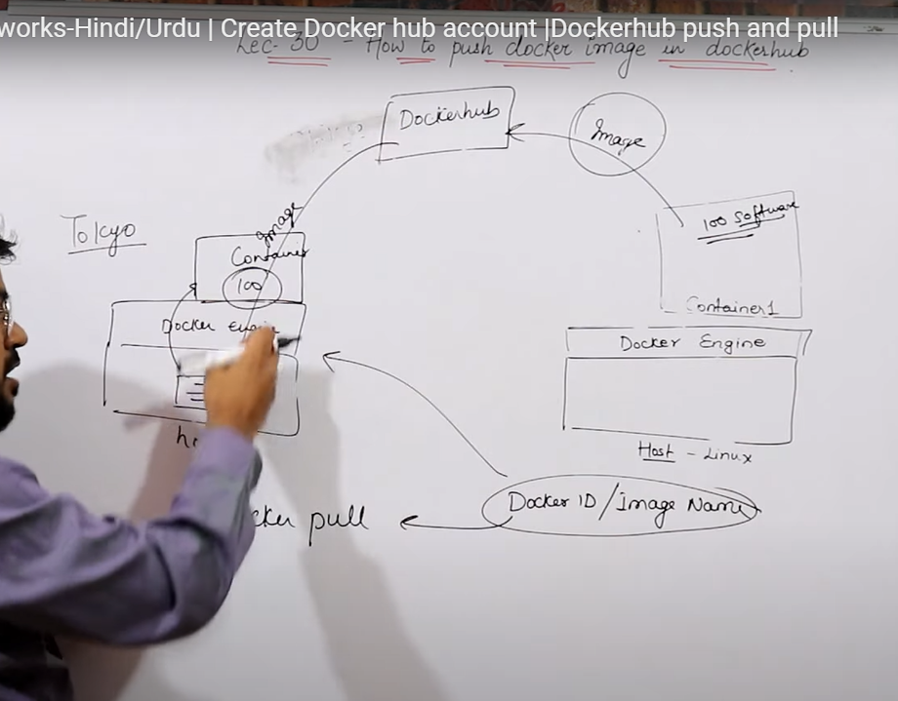

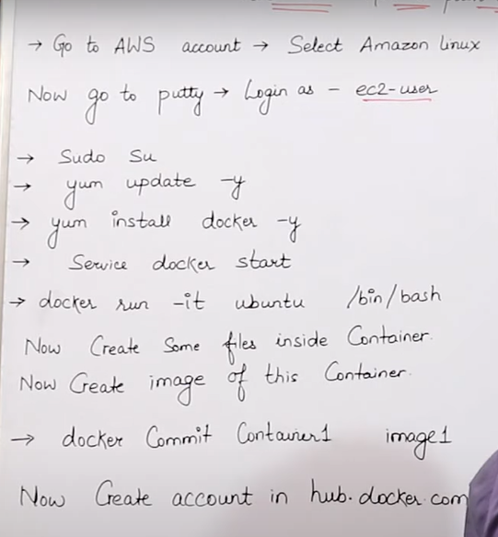

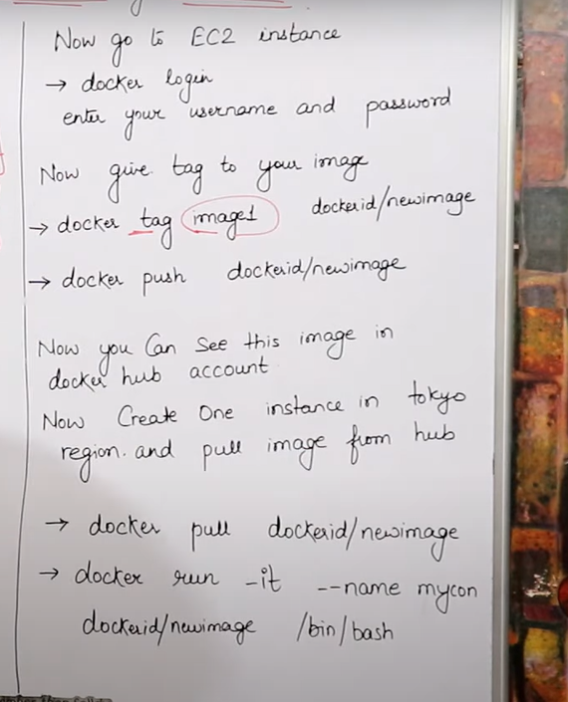

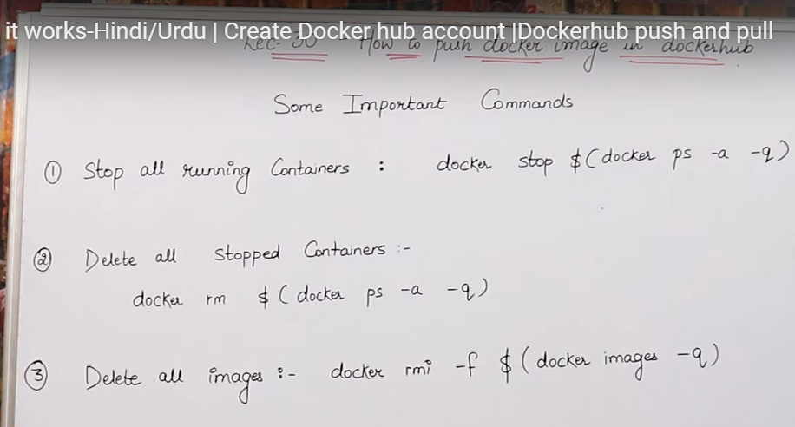

docker commit elastic_wing image1

92 docker login

93 docker tag image1 nitishkumar02/nitishtestimage1

94 docker push nitishkumar02/nitishtestimage1

95 docker login

96 docker pull technicalguftgu/project1

97 history

Go to setting on images and changes it’s visibility to private, will be ale to access only when credential is available